**CONSOLE BASED BANKING APPLICATION**

**SRS Document**

**OBJECTIVE:**

Design a console based application that has following features:

* Takes the input from the user/customer and perform all the banking operations and display the output

**IDENTIFICATION OF NEED:**

* Helps in digitalization of banking transactions
* Performs the daily tasks in no time
* Security and privacy

**PLATFORM SPECIFICATION:**

1. Hardware Requirements

* Laptop with intel core (i5) processor or Mac
* Ram : minimum 4 GB and above
* Storage atleast 256GB and above

1. Software Requirements:

* JAVA, SQL, JDBC,JIRA

**FUNCTIONAL REQUIREMENTS:**

* User Account Management
* Saving and Current accounts
* Transaction Management
* Deposit and Withdraw funds
* Transfer funds between accounts
* Transaction History
* Save a log of all transaction
* Retrieve and display transactions
* Database Operations(Using JDBC)
* Reports
* Statements Generation

**USE CASE DIAGRAM**

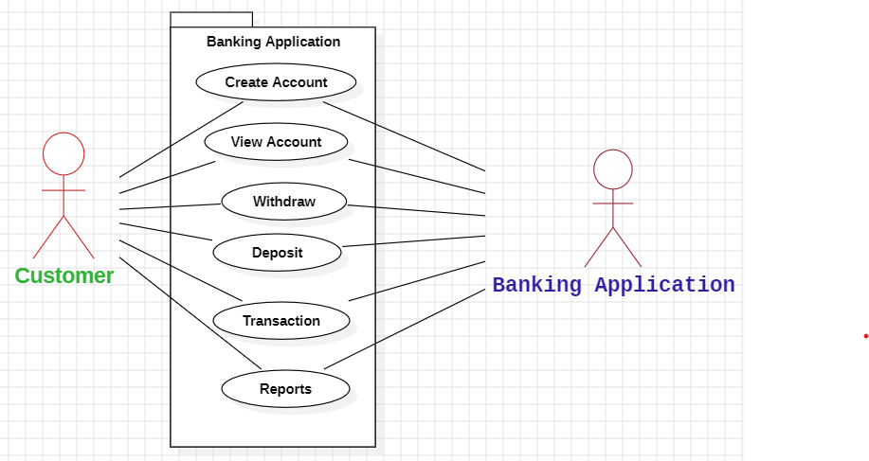

**SCHEMA DESIGN:**

**Bank:** Stores information about the bank

Columns:

* BankId INT Unique (PK)
* Bank_name varchar(50)
* Bank_branch varchar(100)

**Account:** Stores the account details, associated with particular bank

**Columns:**

* Account_ID INT Unique (PK)
* Customer_id INT
* BankID INT(FK)
* Account_Type varchar(20)

**Savings Account and Current Account:** Specialized Tables for different Types, inheriting from Account table

Columns (Saving Account)

* Account_Id INT (FK)
* Interest_rate Decimal(5,2)

Columns (Current Account)

* Account_id INT (FK)
* OverDraft_Limit Decimal (15,2)

**Transaction:** Records all transactions (deposit, withdraw, transfer) linked to account

Columns:

* Transaction_ID INT (PK)
* Account_ID INT (FK)
* Transaction_type varchar(50)
* Amount Decimal(10,2)
* Transaction_date TIMESTAMP

**DepositTransaction, WithdrawTransaction:** Specialized tables for different transaction types, inheriting from the transaction table

1. **Withdraw Transaction:**

* Transaction_id INT (FK)
* Withdrawal_method varchar(20)

1. **Deposit Tranaction:**

* Transaction_id INT (FK)
* Deposit_method varchar(20)

**Schema Diagram:**

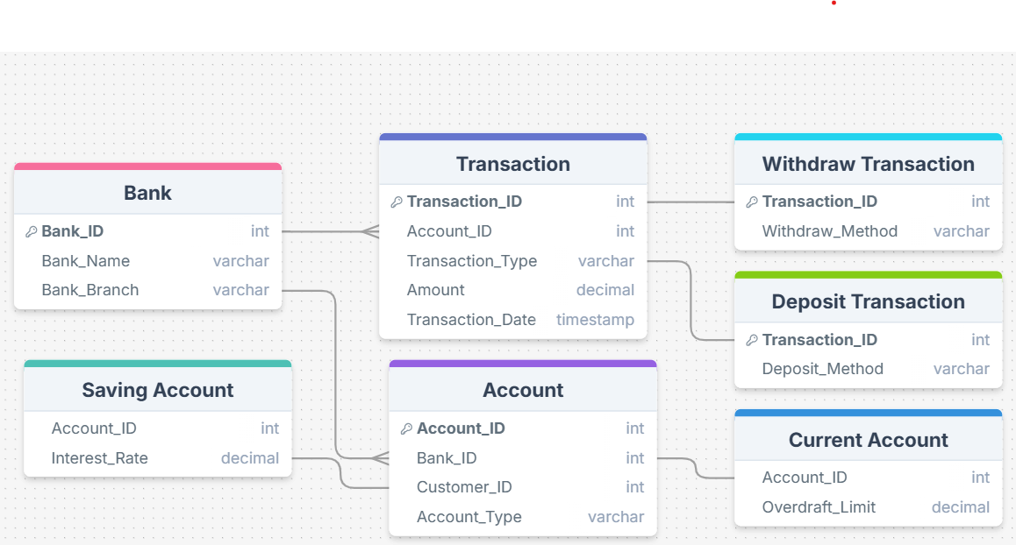

**ENTITY-RELATIONSHIP DIAGRAM**

